Chapter 11, Solution 11.

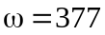, 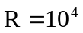, 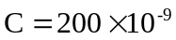
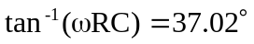

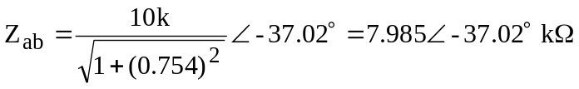

I = 33∠–68˚ mA
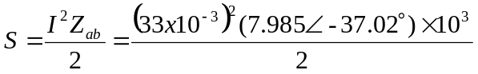
S = 4.348∠–37.02˚ VA

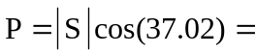3.472 W

